Low-Level Design
_{for}
Design and Development of Identity Security Framework for Finance
Raihana Anzar
23BCCED088
BCA in Cyber Security, Ethical Hacking & Digital Foreignsic with IBM
Yenepoya Institute of Arts, Science, Commerce and Management
Mangalore
11-04-2026
Under the guidance of
Ms. Divya N Shetty
Lecturer, Computer Science Department
Yenepoya Institute of Arts, Science, Commerce and Management
Mangalore
Submitted to


YENEPOYA INSTITUTE OF ARTS, SCIENCE, COMMERCE AND MANAGEMENT
BALMATTA, MANGALORE
YENEPOYA (DEEMED TO BE UNIVERSITY)

Table of Content

- Introduction
1.1 Scope of the Document
1.2 Intended Audience
1.3 System Overview
- System Design
2.1 Application Architecture Diagram
2.2 Process Flow (Dispatch Lifecycle) – Sequence Diagram
2.3 Information Flow (Telemetry Engine) – Data Flow Diagram
2.4 Components Design (Detailed)
2.5 Key Design Considerations
2.6 API Catalogue
- Data Design
3.1 Entity-Relationship (ER) Diagram
3.2 Data Model (Schema & Encryption)
3.3 Data Access Mechanism
3.4 Data Retention & Archival Policies
3.5 Data Migration & Seeding
- Interfaces
4.1 User Interface (UI) Layout
4.2 API Contracts (Request/Response Structure)
- State and Session Management
5.1 Session Implementation
5.2 MFA Re-authentication Decorator
5.3 Logout
- Caching Strategy
- Non-Functional Requirements
7.1 Security Aspects
7.2 Performance Aspects
7.3 Availability & Recovery
- Conclusion

1. Introduction
1.1 Scope of the Document
This Low-Level Design (LLD) defines the low-level implementation logic for the core security modules of the Banking Identity framework. It covers component breakdown, data models, API contracts, state management, caching, and non-functional requirements at a level sufficient for developers to implement the system.

1.2 Intended Audience
- System Developers – to understand module interactions and implement features.
- Security Auditors – to verify cryptographic and access control correctness.
- Institutional Compliance Leads – to map controls to SOX / PCI-DSS requirements

1.3 System Overview
A Python/Flask-based security stack that enforces:
- Multi-Factor Authentication (TOTP) using PyOTP.
- Institutional Role-Based Access Control (Analyst, Auditor, Admin).
- OAuth2 integration (Google Sign-On) for external identity.
- Encrypted data storage (AES-128 Fernet) for sensitive fields.
- Maker-Checker approval workflow for financial transactions.
- Full audit logging with telemetry.
The system is a security prototype – it does not connect to live banking networks but simulates financial operations with realistic controls.

2. System Design
2.1 Application Architecture Diagram (Internal)
The system is modular, with clear separation between presentation, business logic, security middleware, and persistence.
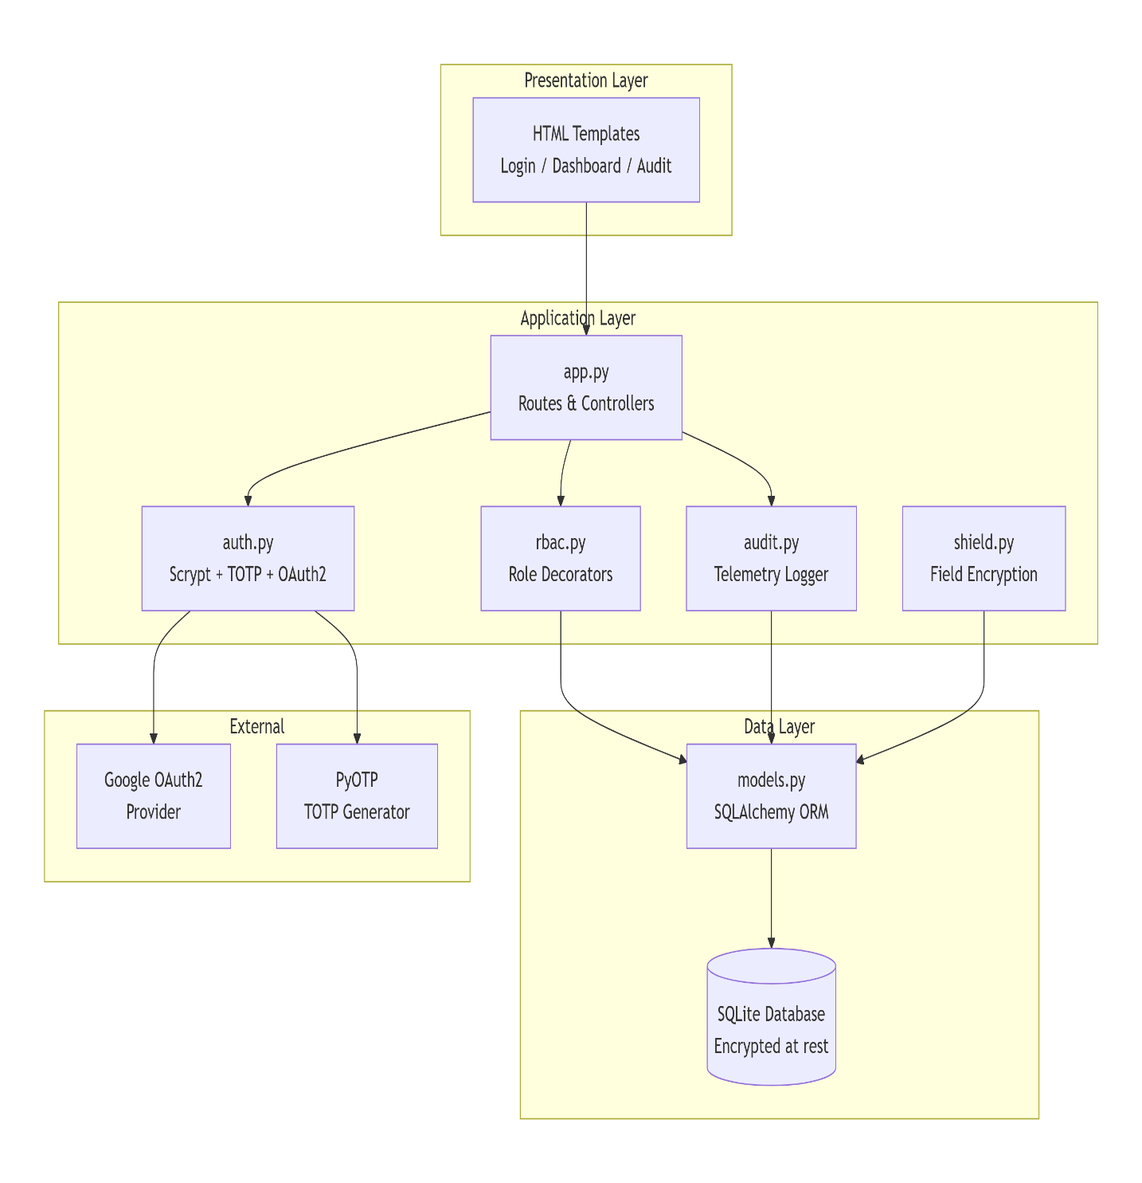
2.2 Process Flow (MFA Handshake) – Sequence Diagram
The MFA handshake is mandatory after primary login. The user must provide a 6-digit TOTP code generated by an authenticator app (Google Authenticator, Authy, etc.).
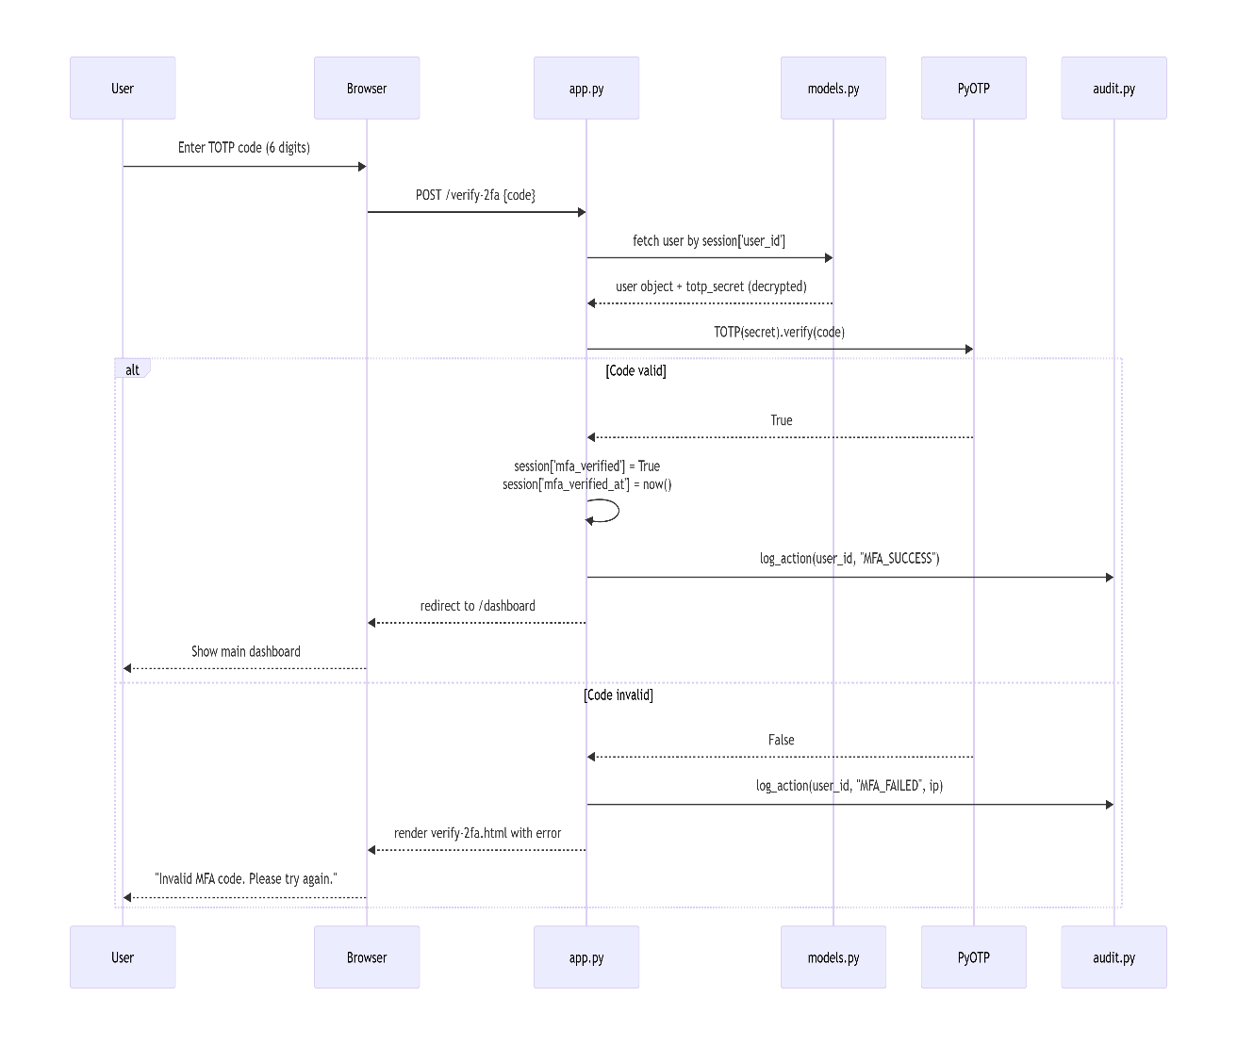

2.3 Information Flow (Telemetry Engine) – Data Flow Diagram
Every sensitive action (login, transaction submit, approval, role change) is logged to the AuditLog table. The audit dashboard reads this table in real time.

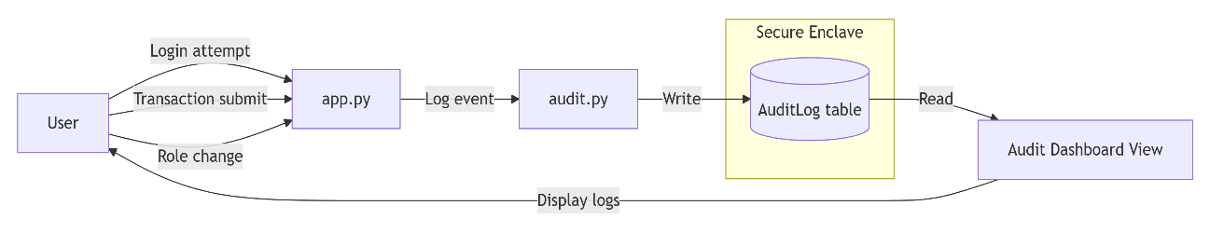

2.4 Components Design
Component | File | Responsibilities | Key Functions / Classes
Authentication | auth.py | Password hashing (Scrypt), TOTP verification, OAuth2 callback handling, session management | hash_password(), verify_password(), verify_totp(), google_callback(), generate_totp_qr()
Authorization | rbac.py | Role-based access control decorators, MFA re-authentication enforcement | @role_required('Auditor'), @mfa_reauth_required
Audit | audit.py | Log user actions (login, transaction, role change, MFA events) to SQLite; retrieve logs for dashboard | log_action(user_id, action, ip, details), get_recent_logs(limit)
Encryption | shield.py | Field-level AES-128 encryption for sensitive data (e.g., account holder name, TOTP secrets) | encrypt_data(plain: str) -> str, decrypt_data(cipher: str) -> str
Models | models.py | SQLAlchemy ORM definitions for User, Account, Transaction, AuditLog, ExchangeRateCache | User, Account, Transaction, AuditLog, PendingTransaction
Main App | app.py | Flask routes, session management, template rendering, error handlers | login(), dashboard(), verify_2fa(), submit_transaction(), approve_transaction()

Password Hashing Flow (Scrypt)
This diagram shows how a user's password is hashed during registration and verified during login, using the specified Scrypt parameters.
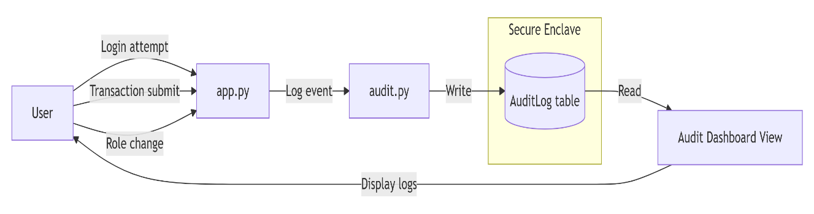

OTP (MFA) Setup and Verification Flow
This diagram covers:
- Setup phase: Generating secret, encrypting it, and showing QR code.
- Verification phase: User enters code, system verifies using PyOTP.
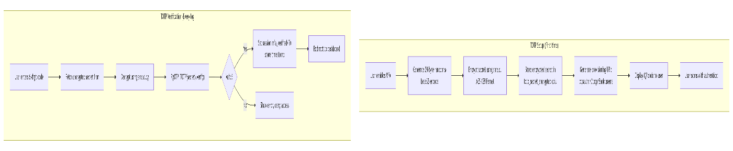

Combined Sequence Diagram (Login + MFA)
For a complete view of the authentication flow including both password and TOTP:
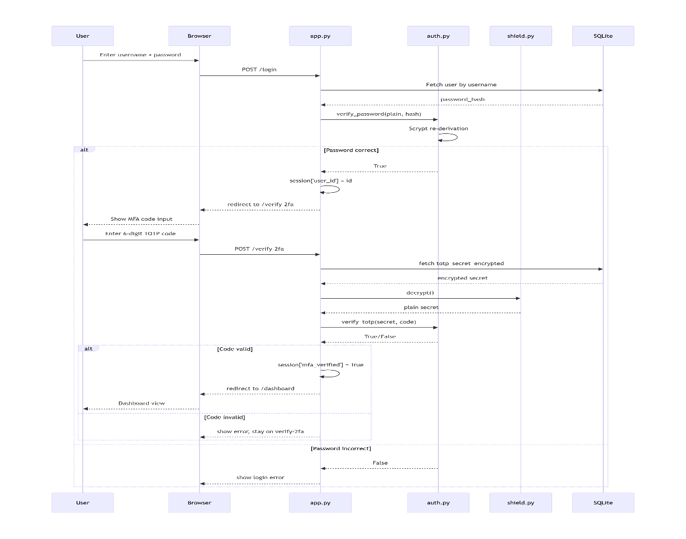

2.5 Key Design Considerations
- Separation of Concerns: Business logic (transaction validation, balance checking) is kept separate from security middleware (MFA, RBAC). This allows independent testing and future changes.
- Fail-Safe Fallback – Password Reset Pipeline:
If a user loses MFA access, the system uses a two-fragment mechanism:
  - pass_prefix stored in User table (hashed)
  - pass_suffix stored in a separate RecoveryFragment table (encrypted)

  - Only an Admin can combine both fragments to generate a temporary reset token.
This prevents a single database compromise from exposing the full password.
- Defense in Depth:
  - Passwords: Scrypt hashed (slow, memory-hard).
  - TOTP secrets: encrypted at rest (Fernet).
  - Account holder names: encrypted at rest.
  - SQLite file: optionally encrypted at OS level (LUKS/BitLocker in production).
  - Network: all communication over HTTPS (TLS 1.2+).
- Least Privilege:
  - Analysts: can view own accounts, initiate transactions (pending approval).
  - Auditors: can approve/reject transactions, view audit logs, but cannot initiate.
  - Admins: full user management, role assignment, recovery operations.

2.6 API Catalogue (Internal)
All endpoints are protected by the specified decorators. Session cookies are used for authentication state.

Endpoint | Method | Protected By | Request Body (JSON or Form) | Response | HTTP Status | Endpoint
/login | POST | None | {username, password} | Set session, redirect to /verify-2fa | 302 redirect | /login
/verify-2fa | POST | Session (user_id present) | {otp_code} | Sets mfa_verified flag | 200 or 400 | /verify-2fa
/dashboard | GET | @login_required, @mfa_reauth_required | – | Renders dashboard HTML | 200 | /dashboard
/analyst/submit_transaction | POST | @role_required('Analyst'), @mfa_reauth_required | {account_id, amount, txn_type, description} | Creates pending transaction, returns JSON | 201 | /analyst/submit_transaction
/auditor/approve_transaction/<id> | POST | @role_required('Auditor'), @mfa_reauth_required | – | Approves transaction, logs approval | 200 | /auditor/approve_transaction/<id>
/auditor/reject_transaction/<id> | POST | @role_required('Auditor') | {reason} | Rejects transaction | 200 | /auditor/reject_transaction/<id>
/admin/users | GET | @role_required('Admin') | – | List all users with roles | 200 | /admin/users
/admin/assign_role/<user_id> | POST | @role_required('Admin') | {role} | Updates role | 200 | /admin/assign_role/<user_id>
/audit/logs | GET | @role_required('Auditor') | ?days=7 | JSON array of audit logs | 200 | /audit/logs
/logout | GET | @login_required | – | Clears session | 302 redirect | /logout

3. Data Design
3.1 Entity-Relationship (ER) Diagram
The database schema supports users, accounts, transactions (with pending approval), and audit logs.

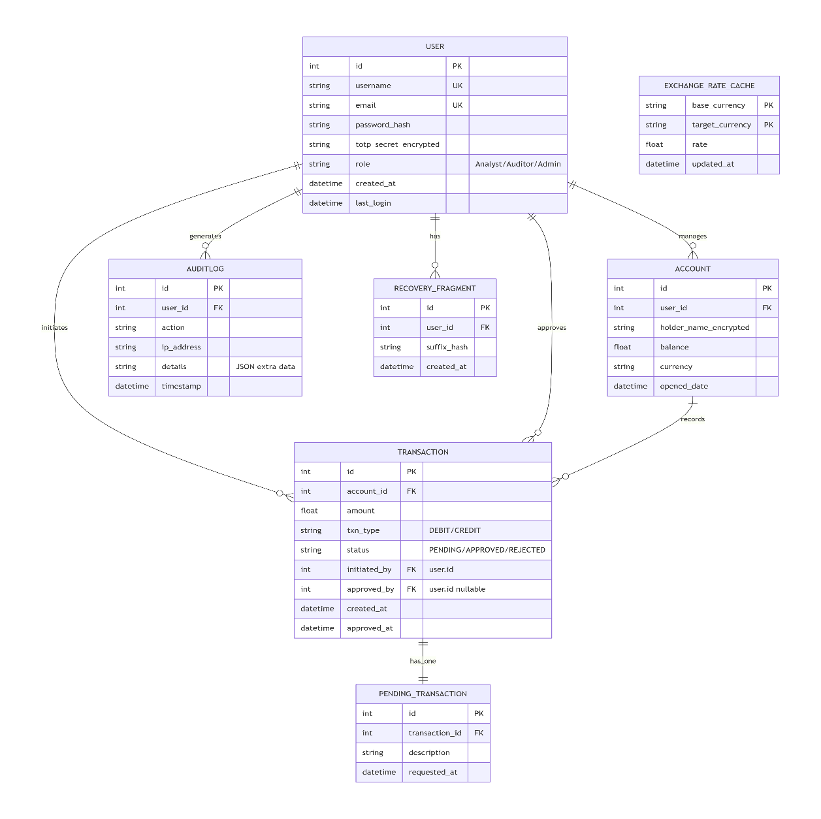

3.2 Data Model (Schema & Encryption)
User:Table
Column | Type | Encryption | Description
id | INTEGER | No | Primary key
username | TEXT | No | Unique, used for login
email | TEXT | No | Used for OAuth2 and notifications
password_hash | TEXT | No | Scrypt hash (includes salt)
totp_secret_encrypted | TEXT | AES-128 (Fernet) | Base32 secret, encrypted
role | TEXT | No | 'Analyst', 'Auditor', 'Admin'
created_at | DATETIME | No | Auto-set
last_login | DATETIME | No | Updated on each login

3.3 Data Migration & Seeding
Managed via seed_finance.py (run once after database creation).
Seed script steps:
- Create roles if not exist (Analyst, Auditor, Admin).
- Create demo users:
- analyst1@bank.com / password Pass@123 (Scrypt hashed)
- auditor1@bank.com / password Pass@123
- admin@bank.com / password Admin@456
- Generate TOTP secrets for each user (for testing, QR codes are printed to console).
- Create sample accounts with encrypted holder names (e.g., "John Doe").
- Insert sample pending transactions for testing the Maker-Checker flow.
- Insert mock audit logs for the last 7 days.
- Rollback: The script checks for existing data and only seeds if tables are empty.

3.4 Data Retention & Archival Policies
Data Entity | Retention Period |  | Enforcement Mechanism | Notes | Data Entity
Audit Logs |  | Minimum 7 years | No automatic deletion; manual archival via separate script | Every login, MFA attempt, transaction submission, approval, rejection, and role change is logged with timestamp. | Audit Logs
Transaction History |  | Permanent (immutable) | No DELETE or UPDATE allowed on Transaction table once status is APPROVED or REJECTED | Soft-delete flags are not used to preserve ledger integrity. | Transaction History
User Records |  | Until account closure + 5 years | active flag; data not physically deleted | Prevents loss of audit trail linking actions to users. | User Records
Exchange Rate Cache |  | 1 hour (TTL) | Automatically overwritten on refresh | No long-term retention needed. | Exchange Rate Cache
Pending Transactions |  | 30 days after rejection | Weekly cleanup job | Rejected pending records are moved to an archive table. | Pending Transactions
3.5 Data Migration & Seeding
Managed via seed_finance.py – idempotent script that populates:
Entity | Demo Data
Roles | Analyst, Auditor, Admin
Users | analyst1, auditor1, admin1 (passwords: Pass@123 / Admin@456)
Accounts | 3 demo accounts with encrypted holder names
Pending Transactions | 2 sample transactions for Maker-Checker testing
Audit Logs | 50 mock events (last 7 days)
Exchange Rates | USD→EUR, USD→GBP, EUR→USD (initial cache)

4. Interfaces
4.1 User Interface (UI) Layout
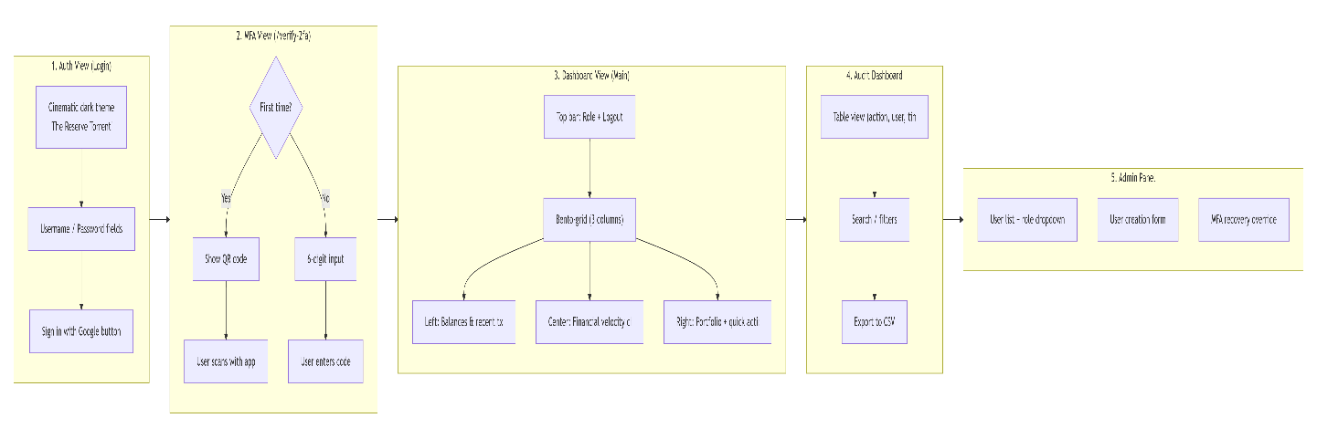

4.2 API Contracts (Request / Response Structure)

POST /analyst/submit_transaction
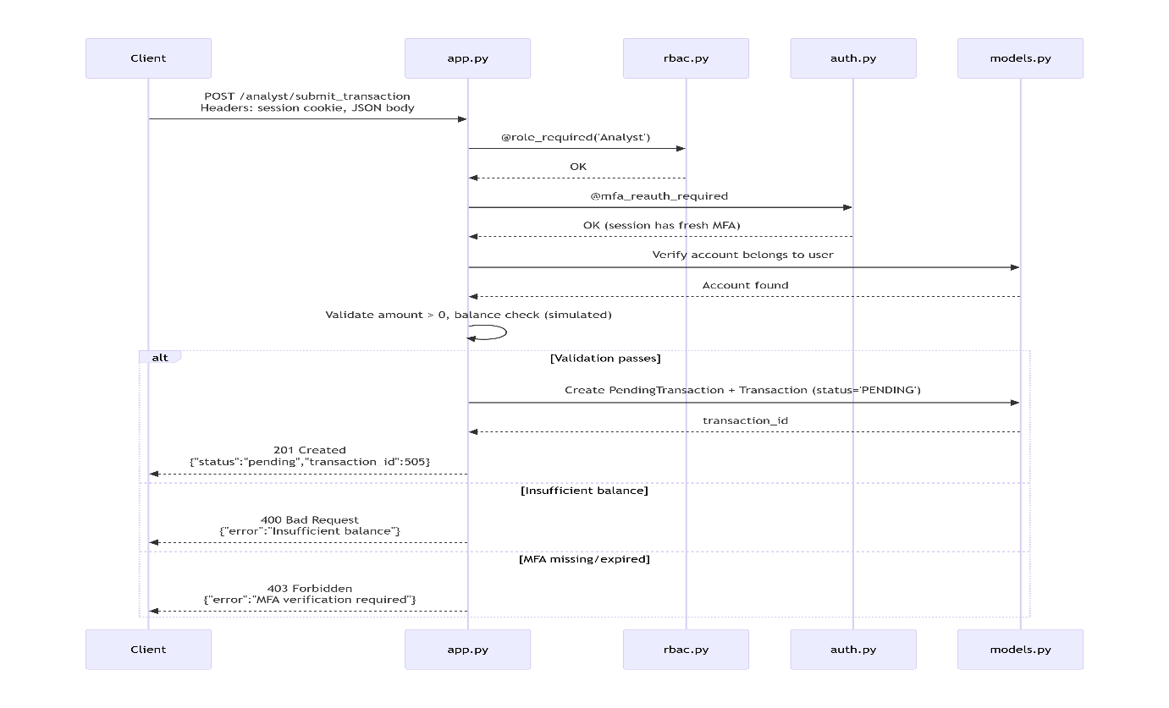
POST /auditor/approve_transaction/<id>
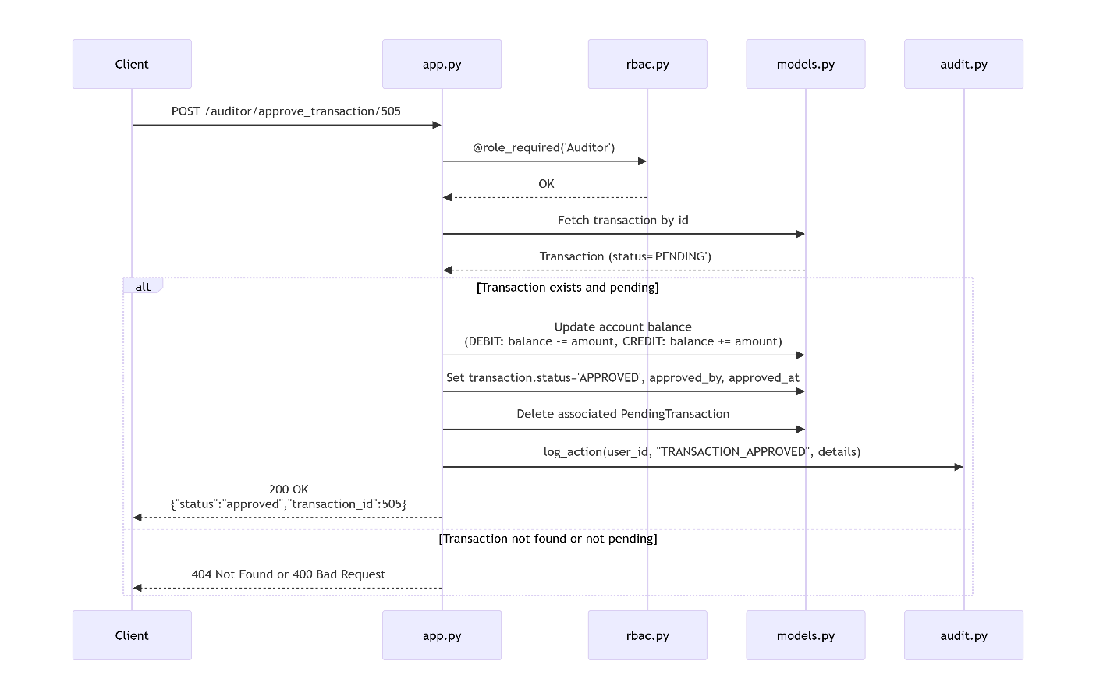

5. State and Session Management
5.1 Session Implementation
- Flask sessions use signed client-side cookies (secret key from SECRET_KEY env var, ≥32 bytes).
- Session contents:
  - user_id (int)
  - role (Analyst/Auditor/Admin)
  - mfa_verified (bool)
  - mfa_verified_at (Unix timestamp)
5.2 MFA Re-authentication Decorator (@mfa_reauth_required)
- Applied to sensitive endpoints (transaction submit, approve, role changes).
- Checks: mfa_verified == True AND (now - mfa_verified_at) < 300 seconds (5 min).
- If fails → redirect to /verify-2fa. After re-verification, update mfa_verified_at.
5.3 Logout
- Clears all session keys → redirect to login page.
6. Caching Strategy (Reduced)
6.1 Exchange Rate Cache (Mock)
- Table exchange_rate_cache stores (base_currency, target_currency, rate, updated_at).
- Refresh: Background thread (Flask-APScheduler) runs hourly, calls mock API (/rates?base=USD&targets=EUR,GBP,JPY), updates cache. On API failure, keeps old rates and logs warning.
- Dashboard usage: Queries cache and displays "1 USD = 0.92 EUR (cached at 14:30)".
6.2 No Other Caching
- Transactional data (accounts, transactions, audit logs) never cached – each read hits DB directly for consistency and auditability.

7. Non-Functional Requirements
7.1 Security Aspects
Control | Implementation
Password hashing | Scrypt (N=32768, r=8, p=1)
TOTP MFA | PyOTP (6 digits, 30 sec)
CSRF | Flask-WTF tokens on all POST forms
CSP | Flask-Talisman: default-src 'self'
Session security | Secure, HttpOnly, SameSite=Lax
Encryption at rest | Fernet (AES-128) for sensitive fields
SQL injection | SQLAlchemy ORM (parameterized)
XSS | Jinja2 autoescaping + CSP

7.2 Performance Aspects
Metric | Target
Login response | < 300 ms
TOTP verification | < 100 ms
Transaction approval | < 50 ms
Dashboard load | < 1 second
Concurrent users | 50 simulated
Database indexes: AuditLog.timestamp, Transaction.status, Transaction.initiated_by
7.3 Availability & Recovery
- Backup: Daily encrypted SQLite ZIP.
- Password reset: Two-fragment fallback (admin-controlled).
- MFA fallback: 10 encrypted recovery codes per user.
- Production note: Use PostgreSQL + replicas (prototype uses SQLite).

8.Conclusion

The Low-Level Design (LLD) v1.0 provides a detailed technical roadmap for the identity-critical portions of the Identity Security Framework for Banking and Finance (The Reserve Torrent Protocol).
All security-sensitive operations – MFA handshake, role-based transaction approval, audit logging, field-level encryption, and password reset fallback – are logically sound, auditable, and ready for implementation. The included Mermaid diagrams (sequence, data flow, ER, component, deployment, state machine) clarify the system’s internal behavior and data relationships.

